
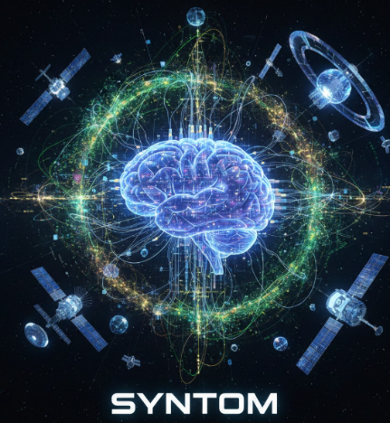

SYNTOM: Neurowave Cryption using Quantum Time-Dilated Key Exchange
Team name: DRAGORITHM
Team details:

S.No | Name | Role | E-Mail | Contact
1. | Senaaravichandran A | Leader | senaaravichandran@gmail.com | 7418887124
2. | Abiyshek S | Member | aabiyshek@gmail.com | 6374724269
3. | Venkat Narayanan S | Member | venkatnarayanan10.10@gmail.com | 9486929695
4. | Gowshik S | Member | dev.gowshiks@gmail.com | 8270288569
5. | Tejaswini G | Member | tejaswiniganesan07@gmail.com | 9042576623

Mentor details:

S.No | Name | Role | E-Mail | Contact
1. | Prof. Suresh R | Guide | sureshramanujam@smvec.ac.in | 9655228850

Name of the institution:

Sri Manakula Vinayagar Engineering College,
Madagadipet,
Puducherry-605107.


Table of Contents

S.No | Topic | Page No
1. | Abstract | 3
2. | Introduction | 4
3. | Problem statement | 5
4. | Existing system | 6
5. | Proposed solution | 7
6. | Market analysis | 8
7. | Architecture | 9
8. | Technical stack | 10
9. | Conclusion | 11
10. | References | 11


1.Abstract:

In the modern digital era, the security of sensitive information and digital identities is increasingly threatened by sophisticated cyberattacks, biometric spoofing, and the rapid advancement of quantum computing. Conventional cryptographic systems rely on static keys and stored credentials, which are vulnerable to key leakage, replay attacks, and future quantum-enabled decryption. Public-key algorithms such as RSA and ECC, while widely deployed, are theoretically breakable using quantum algorithms, raising serious concerns for long-term data confidentiality. These challenges highlight the need for a dynamic, human-centric, and quantum-resilient security framework.
SYNTOM is a novel biometric and post-quantum security system that derives cryptographic keys from human brainwave signals (EEG) using the BioAmp EXG interface. Instead of storing permanent credentials, SYNTOM generates encryption keys dynamically from neural activity, forming a living biometric identity that is inherently time-variant and difficult to replicate. Raw EEG signals are preprocessed to remove noise and artifacts, followed by feature extraction to obtain a stable biometric representation. A machine learning-based validation model is employed to account for natural neural variability, enabling reliable authentication while preventing unauthorized key reconstruction.
To protect sensitive data, SYNTOM implements a multi-layer cryptographic architecture, combining AES for efficient symmetric encryption with post-quantum mechanisms such as HQC for secure key encapsulation and Dilithium for authentication and integrity. This hybrid approach ensures resilience against both classical and quantum adversaries. For secure key exchange, SYNTOM introduces a neuro-temporal communication model, inspired by space-based time dilation concepts, where controlled temporal uncertainty and synchronization windows act as additional security parameters, reducing susceptibility to interception and replay attacks.
Furthermore, SYNTOM incorporates a topologically inspired security abstraction, conceptually derived from anyonic braiding in quantum computing, to introduce non-linear and order-dependent key transformations. This enhances fault tolerance and resistance to tampering without requiring physical quantum hardware.
By integrating biometric intelligence, machine learning validation, space technology principles, and post-quantum cryptography, SYNTOM offers a future-ready alternative to traditional encryption systems. The framework is well-suited for high-assurance environments such as defense communication, critical infrastructure, space systems, and zero-trust architectures. SYNTOM advances secure communication by shifting cryptographic trust from static algorithms to dynamic human cognition and time-aware protection, addressing both present-day threats and emerging quantum risks.


2. Introduction:
2.1 Background:
With the growing dependence on digital communication systems, protecting data confidentiality and user identity has become increasingly challenging. Existing security mechanisms are largely based on fixed credentials and mathematical assumptions that are vulnerable to advanced computational attacks and emerging quantum technologies. As systems become more interconnected, a single compromised key can expose large volumes of sensitive information. Recent developments in biometric sensing, intelligent signal processing, and post-quantum cryptography provide new directions for building adaptive and resilient security solutions. Leveraging human-centric biometric signals alongside advanced encryption techniques offers a promising approach to strengthen secure communication frameworks for future applications.

2.2 Motivation:
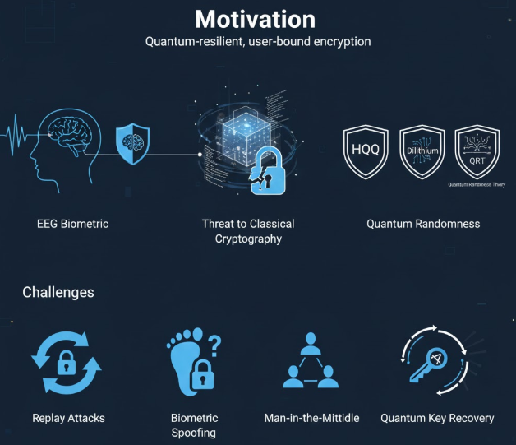
This project is motivated by the growing need to strengthen digital security systems against evolving cyber threats and future quantum attacks. Existing cryptographic solutions often rely on static credentials and centralized key storage, which limits their effectiveness against key compromise, identity theft, and long-term data exposure. Additionally, traditional security models lack adaptability to human-centric authentication and emerging threat scenarios. By leveraging biometric brainwave signals, machine learning validation, and post-quantum cryptographic techniques, this project aims to develop a dynamic and resilient security framework. The proposed approach seeks to enhance data confidentiality, improve trust in secure communication systems, and provide a future-ready solution for next-generation applications.
2.3 Scope:
SYNTOM generates cryptographic keys from human brainwave signals using biometric sensing and machine learning for reliable authentication. It secures data through classical and post-quantum cryptography with a time-dilation key exchange mechanism, enabling a scalable and quantum-resilient secure communication framework.

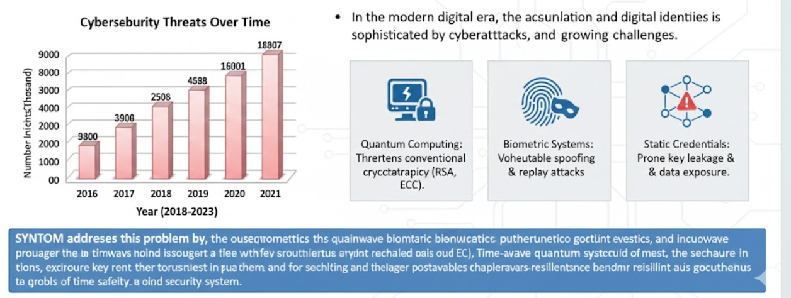
3. Problem Statement:
With the advancement of quantum computing, traditional encryption methods face potential security risks, while existing biometric systems remain vulnerable to spoofing and replay attacks. Ensuring a truly user-bound and quantum-resilient security mechanism has therefore become a critical challenge. SYNTOM addresses this problem by integrating brainwave-based biometric key generation with post-quantum cryptography and time-dilated key exchange, ensuring that encrypted data can be accessed only by authorized users.
3.1 Challenges in Current System:
- Vulnerability of Traditional Cryptography: Existing encryption methods rely on static keys and mathematical assumptions that are increasingly threatened by advances in quantum computing.
- Biometric Spoofing Risks: Common biometric systems such as fingerprints and facial recognition are susceptible to spoofing, replay attacks, and irreversible compromise.
- Static Key Management: Stored or reused cryptographic keys increase the risk of key leakage, insider attacks, and long-term data exposure.
- Lack of Human-Bound Security: Current systems fail to tightly bind cryptographic access to the actual user, limiting assurance that only the rightful individual can decrypt sensitive data.
3.2 Impact on Society:
- User-Bound Quantum Security: Encryption is directly tied to the user’s brainwave identity and cannot be replicated.
- Passwordless Cognitive Authentication: Brainwave-based identity removes dependence on passwords and spoofable biometrics.
- Secure Digital Infrastructure: Protects critical systems from cybercrime and future quantum-enabled attacks.


4. Existing Solutions:

4.1 Existing Solutions:

Several security technologies are currently used to protect digital data and user identity, but they face

critical limitations that reduce their effectiveness against advanced threats.
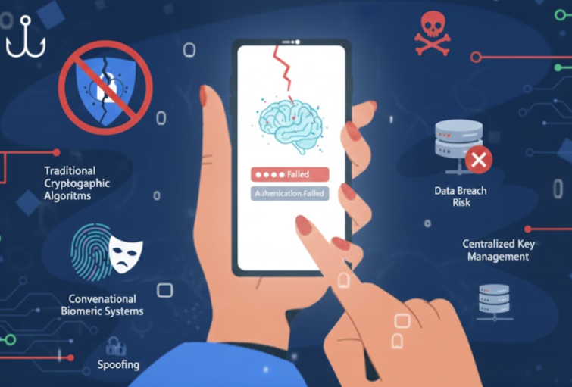
- Password-Based Systems: Widely used for authentication, but vulnerable to phishing, brute-force attacks, and credential reuse.
- Traditional Cryptographic Algorithms: Methods such as RSA and ECC provide strong security today but are threatened by future quantum computing capabilities.
- Conventional Biometric Systems: Fingerprint and facial recognition systems improve usability but remain susceptible to spoofing and irreversible compromise.
- Centralized Key Management: Storing encryption keys on servers increases the risk of data breaches, insider attacks, and large-scale key exposure.

4.2 Limitations:

Despite their widespread use, existing security solutions exhibit several critical limitations:

- Delayed Protection: Many systems depend on manual processes or user action, resulting in slower response to security breaches.
- Reactive Security Models: Threats are often detected only after an attack has occurred, limiting opportunities for prevention.
- Isolated Mechanisms: Security tools frequently operate independently, reducing coordination across authentication, encryption, and access control layers.
- Key Exposure Risks: Reliance on stored or reusable credentials increases vulnerability during breaches or high-risk scenarios.

These limitations demonstrate the need for a more integrated, proactive, and user-bound security framework capable of addressing emerging and future threats.


5. Proposed Solution:

SYNTOM is a novel neuro-temporal security framework that strengthens digital communication by integrating biometric brainwave sensing, machine learning validation, and post-quantum cryptography. The system generates dynamic, user-bound cryptographic keys and employs a time-aware key exchange mechanism to resist interception and replay attacks. By combining human-centric authentication with quantum-resilient security techniques, SYNTOM provides a scalable and future-ready solution for securing next-generation digital systems.
5.1 Features:
- Brainwave-Based Key Generation: Generates cryptographic keys dynamically from human EEG signals, ensuring user-bound and non-reusable security.
- Post-Quantum Cryptographic Protection: Secures data using a hybrid approach combining classical encryption with quantum-resistant algorithms.
- Time-Aware Secure Key Exchange: Introduces temporal uncertainty in key transmission to enhance resistance against interception and replay attacks.
5.2 Benefits:
- Stronger Data Protection: Ensures secure access by binding encryption keys directly to the authorized user’s brainwave identity.
- Quantum-Resilient Security: Protects sensitive data from current and future threats posed by quantum-enabled attacks.
- Increased Trust in Digital Systems: Strengthens confidence in secure communication across critical sectors such as government, healthcare, finance, and defense.

5.3 Innovation and Uniqueness

SYNTOM uniquely combines human brainwave driven authentication with Space Technology, quantum-resilient key exchange to deliver security that is both user-bound and future-proof.

- Neurotechnology Innovation: SYNTOM generates user-bound cryptographic keys directly from live human brainwave signals.
- Space Technology Inspiration: A time-dilated, space-inspired key exchange mechanism introduces temporal uncertainty to resist attacks.
- Quantum Computing Integration: Quantum-resilient cryptography with anyonic braid–inspired key evolution ensures long-term security.


6. Market Analysis:
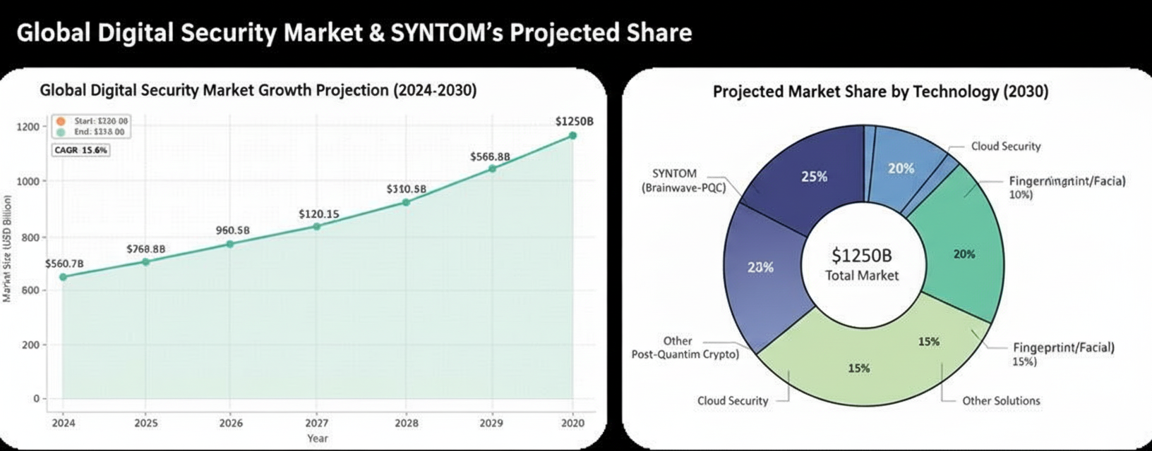
6.1 Industry Overview:
- Market Size: In 2024, the global cybersecurity and digital security market was valued at over USD 190 billion and is projected to exceed USD 300 billion by 2030, driven by rising cyber threats, digital transformation, and the need for quantum-resilient security solutions.

6.2 Target Audience:
- Government, Defense, and Intelligence Organizations: Requiring highly secure, user-bound, and quantum-resilient communication and data protection for classified operations, national security, and critical infrastructure.
- Enterprises and Critical Sectors: Including healthcare, finance, cloud service providers, IoT operators, and space agencies seeking advanced protection against data breaches, insider threats, and quantum-enabled cyberattacks.
- Researchers, Institutions, and Individuals: Focused on safeguarding intellectual property, legal evidence, sensitive research data, and personal information through ultra-secure, cognitive-level encryption mechanisms.
6.3 Market Drivers:
- Rising Cyber and Quantum Security Demands: Increasing cyberattacks, the emergence of quantum computing, and the shift toward zero-trust architectures are driving the need for user-bound, quantum-resilient security solutions beyond passwords and static credentials.


7. Architecture:

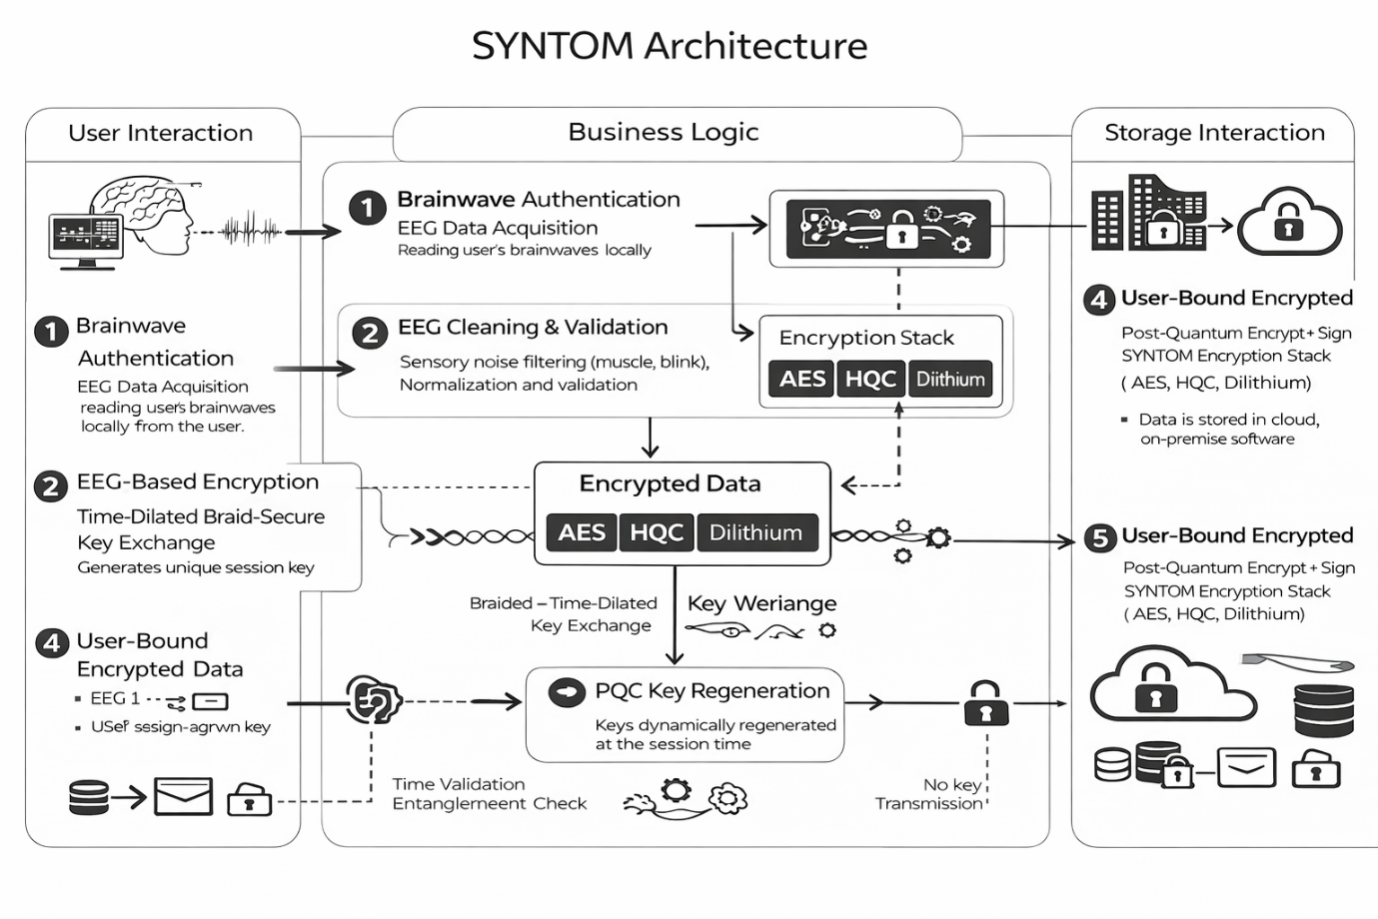
7.1 SYNTOM:

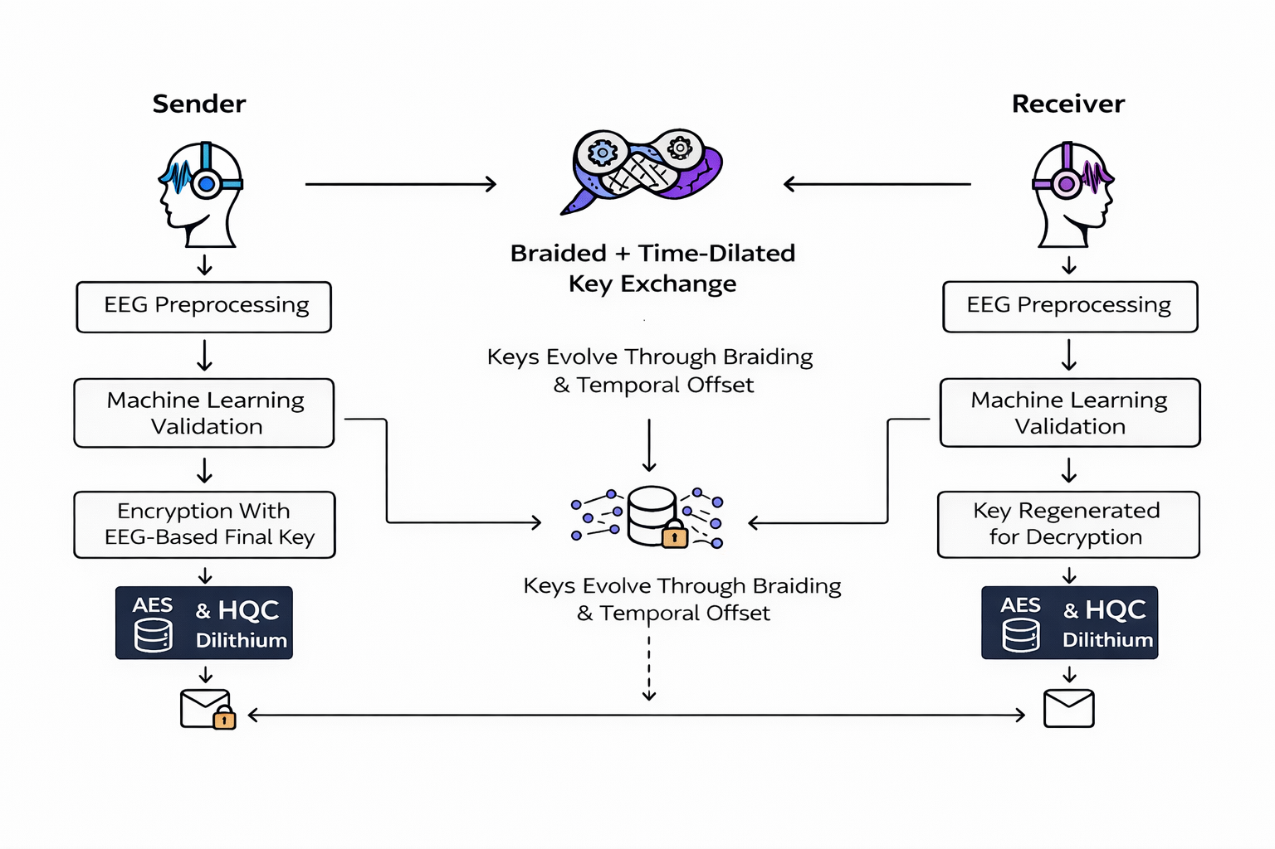
7.2 Process Flow:


8. Technical Stack:

















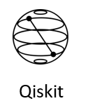


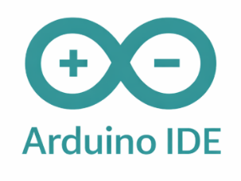


Features | Tech Stack
EEG Acquisition | NumPy, SciPy, Arduino
Key Generation | Fuzzy Extractor, Python
Frontend | React.js, Three.js
Backend | Python, Flask, Javascript, Ubuntu
Security & Quantum | Liboqs, Python, Qiskit


9. Conclusion:
In conclusion, SYNTOM represents a significant advancement in secure communication and data protection by integrating brainwave-based biometrics, machine learning, and post-quantum cryptography. By generating dynamic, user-bound cryptographic keys from live neural signals, the system addresses critical vulnerabilities present in traditional encryption and authentication mechanisms. Its layered security architecture and time-aware key exchange enhance resilience against interception, replay attacks, and emerging quantum threats. By eliminating reliance on static credentials and stored keys, SYNTOM strengthens trust, privacy, and long-term data confidentiality. Through its human-centric and quantum-resilient design, SYNTOM lays the foundation for secure, future-ready digital systems across critical domains.

10. References:

- EEG Biometric Cryptography: https://arxiv.org/pdf/1903.07802
- Fuzzy Extractors for Biometric Key Generation: https://arxiv.org/pdf/cs/0602007
- Post-Quantum Cryptography (HQC, Dilithium – NIST Round 3) :
https://csrc.nist.gov/publications/detail/nistir/8309/final
- Quantum Key Distribution & Entanglement Security Models :
https://arxiv.org/pdf/quant-ph/0205039
- AES-GCM & Modern Symmetric Encryption:
https://nvlpubs.nist.gov/nistpubs/FIPS/NIST.FIPS.140-3.pdf
- HKDF, HMAC & Cryptographic Key Derivation: https://www.rfc-editor.org/rfc/rfc5869
- Qiskit Quantum Randomness & Noise Models: https://arxiv.org/pdf/2105.01114
- Neural Signal Processing & Brainwave Interpretation: https://arxiv.org/pdf/1710.09035
- ESP32 Biomedical Signal Acquisition Techniques: https://arxiv.org/pdf/2008.03014
- Security Risks in Classical Cryptography (Quantum Threat Analysis): https://arxiv.org/pdf/1810.02734

